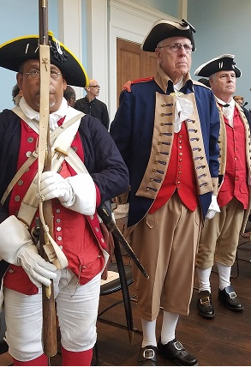

Philip Monroe Anders
February 2, 1944 to July 21, 2020 (age 76)

Posted on July 26, 2020July 26, 2020 by dany
February 2 1944 July 21 2020 (age 76)

Obituary Philip Monroe Anders, 76, of West Chester, PA, formerly of Malvern, PA, passed away after a long battle with cancer on July 21, 2020 peacefully, at home surrounded by his family. Phil was born in 1944 in Ardmore, PA to the late James M. and Jeannette R. (Rudolph) Anders. He attended Lower Merion High School (’61) and Lycoming College (’65). He married Nancy (Dietrich) Anders in 1967, had 2 daughters and they settled in Chester County.

Phil worked in the Banking industry for over 40 years, rising from Teller to Executive. During this time, he actively volunteered in numerous professional organizations. For 39 years, he served and earned a retirement rank of Master Sergeant in the United States Army Reserve. Phil relished life and stayed active with music, sports and volunteer work. He sang with the 49ers Chorus of West Chester, Wayne Oratorio Society, Calvary Lutheran Church, New Horizons Senior Chorus and the Hershey’s Mill Singers. He was an avid softball player, often rostered on 3 teams at the same time. He played golf throughout his life and he loved to join a pickup basketball game, using his size and agility to play alongside players half his age as well as watching basketball of all levels.

A Life member of the Philadelphia Continental Chapter of the Sons of the American Revolution, he served as President (twice), Captain of the Color Guard and on several National committees.

His work and involvement in all of these organizations had his life intersecting with the lives of so many, and he could run into someone he knew everywhere he went. Phil planned his days around his rehearsals, committee meetings or golf with his regular foursome, with a keen eye on getting to the field hockey and baseball games, music and theater performances, swim meets, or soccer and basketball games of his four grandchildren or to a game of his own. He loved to travel in the US and abroad and always had his annual trips to Sanibel Island, FL and National SAR Headquarters at the top of each year’s itinerary.

Phil is survived by his loving wife of 53 years, Nancy (Dietrich) Anders, daughters Debra (Garrick) Weaver and Susan (Peter) Brizick, and grandchildren, Lauren (19), Andrew (13), Alexis (11), and Ryan (11). He is also survived by his cousin, James (Pam) Anders. Phil was a supportive, warm, kind-hearted soul. He always had a smile, a well thought word and sound advice. He also always had a story to tell and often broke into a song. He will remain in our hearts and minds forever. A memorial service will be held at a future date.

To be kept apprised of details for this service or to share a private message with the family, please email philandersmemorial@gmail.com. In lieu of flowers, donations may be made in his honor to: Calvary Lutheran Church Music Fund, where he enjoyed singing alongside Nancy as well as his daughter Susan and grandsons Andrew and Ryan, at Calvary Lutheran Church Music Fund, 730 S. New Street, West Chester, PA 19382, The Lymphoma Research Foundation (www.lymphoma.org) or a charity of your choice. To send flowers to the family or plant a tree in memory of Philip Monroe Anders, please visit our floral store.

Our most sincere sympathies to the family and friends of Philip Monroe Anders February 2 1944 July 21 2020 (age 76).

Ralston & Bredickas Funeral Home Ltd

Death notice for the town of: Downingtown, state: Pennsylvania

death notice Philip Monroe Anders February 2 1944 July 21 2020 (age 76)
obituary notice Philip Monroe Anders February 2 1944 July 21 2020 (age 76)

