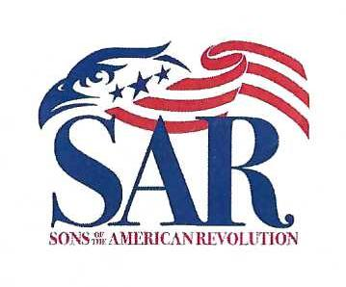
Philadelphia Continental Chapter
Sons of the American Revolution
Installation of Officers
Dinner Meeting
Friday November 5th, 2021, at 5:30 PM
Overbrook Golf Club
799 Godfrey Road, Villanova, PA
The Installation of Officers Dinner Meeting of the Philadelphia Continental Chapter, Sons of the American Revolution, will be held at the Overbrook Golf Club on Friday, November 5th, 2021, at 5:30PM. The installation will occur after dinner is served. Overbrook has proved to be an excellent choice, with fine food, special service, and an elegant setting at modest cost. Dinner will consist of a gourmet filet mignon, salmon or vegetarian meal preceded by a cash bar with served hors d’oeuvres. The total cost is $80.00 per person and preferred dress is formal - Black Tie - with military and SAR medals.
5:30 PM - Cash bar and reception 6:15 PM - Welcome 6:30 PM - Dinner and program
Name ___________________________________________
Guest ___________________________________________
Guest ___________________________________________
Dinner will be served with salad and vegetable.
If you receive a “.pdf” of this form just enter the number next to your meal selection(s) and the form will calculate your total cost.
Filet mignon ______ Salmon ______ Vegetarian ______
Number of meals selected ______ for a total of: ____________
Please make your check payable to PCCSAR and mail by October 22nd to:
Compatriot Bill Baker: 929 Burmont Rd; Drexel Hill, PA 19026-4012
Directions to Overbrook Golf Club as follows; Take exit 13 from the Blue Route (I 476) Villa- nova- St Davids. Turn right at end of exit ramp for Rt 30 east (Lancaster Ave). Go less than one mile to Rt 320 (Sproul Rd), turn right, At second light, turn right onto Godfrey Rd. Overbrook Golf Club is a short distance down Godfrey Rd, on the left.

